# Lab 1 Basic HTML, CSS and JavaScript

Based on the examples of creating tables, create a front-end only Jokes app.

You need to create up to to 10 jokes and emulate data retrieved from the backend as demonstrated in the tables2 demo.

The output should look something like the following – choose your own style:

If one joke is requested, display the setup and punchline of the joke on separate lines. E.g.

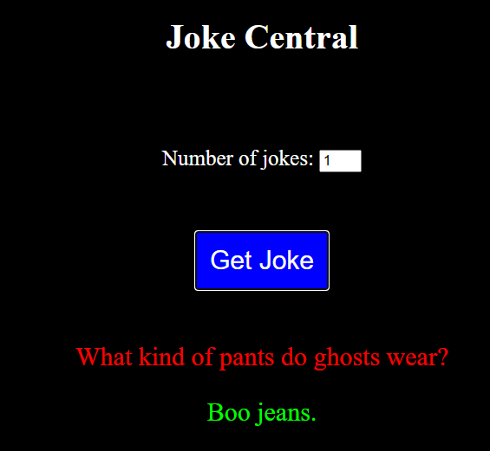

If more than one joke is requested, display them in a table. E.g.

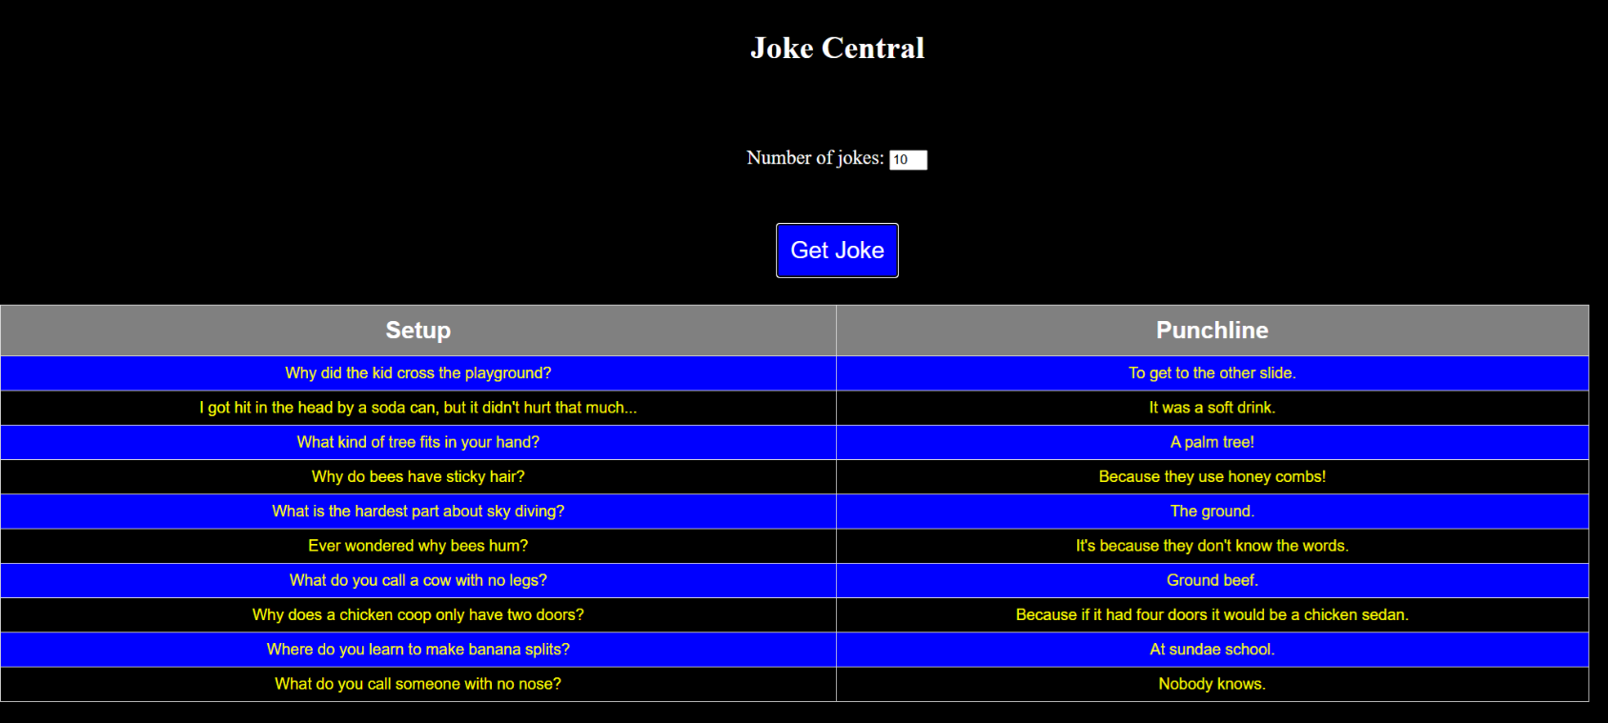

Your solution should be available to be seen on request